Reprezentarea grafica a functiilor reale

Pentru a trasa graficul unei functii , parcurgem mai multe etape :

1) Domeniul maxim de definitie
a) gasirea domeniului maxim de definitie
b) Gf ∩ Ox => f(x)=0
c) Gf ∩ Oy => x=0 , f(x)= o valoare
d) $\underset{x→±∞}{\text{lim}}f(x)$ ( daca e constanta => y=k => asimptota orizontala )

2) Semnul functiei
a) semnul functiei
b) paritatea functiei
f(x)=f(-x) => functia e simetrica fata de axa Oy
f(x)=-f(x) => functia e simetrica fata de origine
c) continuitatea functiei
d) periodicitatea

3) Asimptote
- orizontale
- verticale
- oblice

4) Derivata intai
- calculul derivatei intai
- radacinile derivatei intai si valorile funtiei pe radacinile derivatei
- tabelul

5) Derivata a doua
- calculul derivatei a doua
- radacinile derivatei a doua si valorile functiei pe radacinile derivatei
- determinarea punctelor de inflexiune , de maxim si minim local
- semnul derivatei a doua
6) Tabelul de variatie al functiei

X
F’(x)
F’’(x)
F(x)

7) Trasarea graficului
- in grafic se incepe cu trasarea asimptotelor

Exemple:

f(x)=$x^{4}−{8x}^{2}$
1)a)f:R→R

b)f(x)=0
$\begin{aligned}x^{4}−{8x}^{2}=0 \\ x^{2}(x^{2}−8)=0 \\ x_{1}=x_{2}=0 \\ x_{3}=2\sqrt{2} \\ x_{4}=−2\sqrt{2}\end{aligned}$

c)f(0)=0-0=0

d)$\underset{x→±∞}{\text{lim}}f(x)=±∞$

2)
a)
x | $−2\sqrt{2}$ 0 $2\sqrt{2}$
$$x^{2}$$ | +++++++++++++++++++++++0++++++++++++++++++++++++++
$$x^{2}−8$$ | ++++0-------------------------------------------0+++
f(x) | ++++0-------------------0-----------------------0+++

b)f(x)=f(-x)
=> functie para
=> graficul este simetric fata de axa Ox

3) Asimptote nu exista

4) Derivata intai
f’(x)=$4x^{3}−\text{16}x=4x(x^{2}−4)$
$\begin{aligned}x_{1}=0 \\ x_{2,3}=±2\end{aligned}$

f(0)=0
f(2)=-16
f(-2)=-16

x | -∞ -2 0 2 +∞
x | -----------------------0+++++++++++++++++++++++++
$$x^{2}−4$$ | +++++++++++0----------------------0++++++++++++++
f’(x) | -----------0+++++++++++0----------0++++++++++++++

5) Derivata a doua
f’’(x)=$\text{12}x^{2}−\text{16}$
$x_{1,2}=±\frac{2\sqrt{3}}{3}$ $f(\frac{2\sqrt{3}}{3})=−\frac{\text{80}}{9}$ $f(−\frac{2\sqrt{3}}{3})=−\frac{\text{80}}{9}$

X | -∞ $−2\sqrt{2}$ -2 $−\frac{2\sqrt{3}}{3}$ 0 $\frac{2\sqrt{3}}{3}$ 2 $2\sqrt{2}$ +∞
f’(x) | -------------0+++++++++++0-----------0+++++++++++++
f’’(x) | +++++++++++++++++++0-----------0+++++++++++++++++++
f(x) | -∞-----0----16+++$−\frac{\text{80}}{9}$----0+++++$−\frac{\text{80}}{9}$---16++++0+++++∞  m i M i m

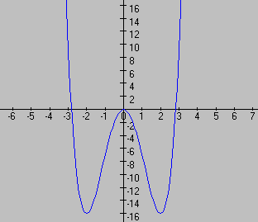
f(x)=$\frac{x^{2}−\text{16}}{x}$
1)a)f:R\{0}→R

b)f(x)=0
$\begin{aligned}x^{4}−\text{16}=0 \\ x_{1}=4 \\ x_{2}=−4\end{aligned}$ A(4,0) ; B(-4,0)

c)f(0)= nu exista

d)$\underset{x→±∞}{\text{lim}}f(x)=±∞$

2)
a)
x | -∞ -4 0 4 +∞
$x^{2}$-16 | +++++++++++++0------------------------0+++++++++++++
x | -------------------------0++++++++++++++++++++++++++
f(x) | -------------0+++++++++++|-------------0++++++++++++

x∈(-∞,-4)∪(0,4) => f(x)<0
x∈(-4,0)∪(4,+∞) => f(x)>0

b)f(x)=f(-x)
=> functie para
=> graficul este simetric fata de axa Ox

c)functia este continua pe R\{0}

3) Asimptote

y=x => asimptota oblica la ±∞
$\underset{x→0}{\text{lim}}f(x)=\frac{x^{2}−\text{16}}{x}=\frac{−\text{16}}{0+}=∞$ => x=0 asimptota verticala la ±∞

4) Derivata intai

f’(x)=$\frac{x^{2}+\text{16}}{x^{2}}>0$

5) Derivata a doua

f’’(x)=$\frac{x−\text{32}}{x^{3}}$

X | -∞ 0 +∞
f’(x) | +++++++++++++++++++++++++|+++++++++++++++++++++++++
f’’(x) | +++++++++++++++++++++++++|-------------------------
f(x) | -∞ | +∞

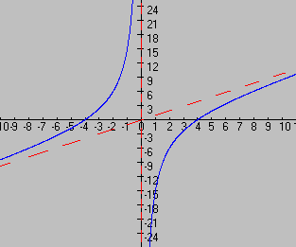

Alte grafice de functii :
1)f(x)=$−x^{3}+3x$ 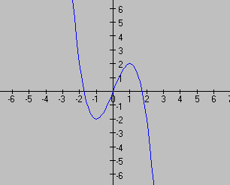
2)f(x)=$3x^{3}−\text{27}$
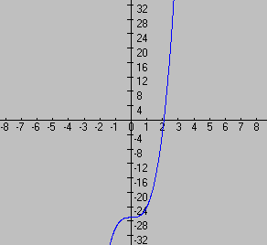

3)f(x)=$x^{5}−5x^{4}$
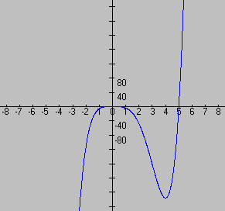

4)f(x)=$\frac{2x}{x^{2}+1}$
